INTRODUCTORY LETTER
Carriers Registration Process
This letter describes the Manual Onboarding support for Carriers into the EES / ETIAS Web Service, enabling Carrier conducted security checks of TCNs, prior to TCN arrival to the EU.
The Manual Onboarding covers the following interactions:
- Registration of Carrier legal entities and their single point of contact (Carrier SPOC)), as well as Carrier Service Provider contacts;
- Exchange of the Non-Disclosure Agreement (NDA) and the Encryption Key;
- Registration of Channel preferences for automated communication System-to-System (Sys2Sys);
- Support for the Sys2Sys Interface compliance tests;
- Answers to questions related legislation aspects, project setup, organisational changes, technical aspects, EES / ETIAS Web Service evolution roadmap.
Important notice:
- All documents sent by eu-LISA, which are not for public domain, are encrypted using an encryption / decryption key that is shared with you;
- The Manual Onboarding lifecycle coverage is focussing on Carriers that need early involvement due to System-to-System (Sys2Sys) testing.
Limitations:
- Onboarding is limited to support prior to the Carrier Entry Into Operations (EIO). Sys2Sys support is covering activities up to Carrier compliance test. Carrier Production support is not included;
- Carrier activities related to transition to operations, Carrier pilots, Carrier end-user related activities such as training or end-user connection testing are not supported;
- Support for the registration of individual Carrier staff for web and mobile use by Manual Onboarding is limited to the registration of the Carrier contact that would register such users (in cases where this is not the Carrier SPOC).
For support outside of these limitations the Self-Service Onboarding and Support shall be made available at a later stage.

    - Manual Onboarding Overview
During the Manual Onboarding process steps, the following information is exchanged:

Table 4 – Overview of information exchanged
# | Information to Carrier | Cipher | How | When | From
01 | Introductory Letter, including  - Carrier Registration form  - Carrier Contact Registration form  - NDA form | Plain-text | Download | Anytime | Working-Group-for-Carriers
02 | Encryption Keys | Plain-text | SMS | Registered and  NDA signed | SMS Gateway (no reply)
03 | Welcome Pack, including  - Introductory letter with forms, as listed under point 1  - Registration form for Carrier System and Service Provider contacts  - Form for Request to be connected  Form to report Test Incident | En-crypted | email | Encryption keys shared | carriers_onboarding@eulisa.europa.eu
04 | Carrier Technical Guidance | En-crypted | email | Carrier System registered | carriers_onboarding@eulisa.europa.eu
05 | Carrier Compliance Test Plan | En-crypted | email | Carrier System registered | carriers_onboarding@eulisa.europa.eu
06 | Test Detail Descriptions | En-crypted | email | Carrier System registered | carriers_onboarding@eulisa.europa.eu

As seen from a Carrier, the Manual Onboarding Process starts with the following Steps:
Preconditions:
The Carrier SPOC has visited the public web page at https://www.eulisa.europa.eu/About-Us/Organisation/working-group-for-carriers and picked up this “Introductory Letter” which provides information about how to onboard via the Manual Onboarding service.
Process steps
- The Carrier SPOC registers the Carrier Enterprise by sending an e-mail titled: “Carrier Registration Request”, to dedicated e-mail: carriers_onboarding@eulisa.europa.eu.
  - This includes registration of the Carrier SPOC as first contact;
- If applicable, the Carrier SPOC registers other Carrier contacts;
- If applicable, the Carrier SPOC registers a System Contact for System-to-System access;
- In case eu-LISA requires clarification during one of these steps, eu-LISA service desk operators will contact the sender via email;
- All registered contacts submit a completed Non-Disclosure Agreement (NDA).
  - This also applies to the Carrier SPOC;
- Contacts that have delivered a NDA will receive a text message with encryption keys;
- These encryption keys are used to encrypt email attachments during the Manual Onboarding email interactions.
Notice:
Exchange of all emails is done through carriers_onboarding@eulisa.europa.eu.

    - Carrier Registration
The form to be used for Carrier Registration is attached Table 11 – Registration Forms.
Carrier Registration steps are depicted below:

Figure 5 – Carrier Registration

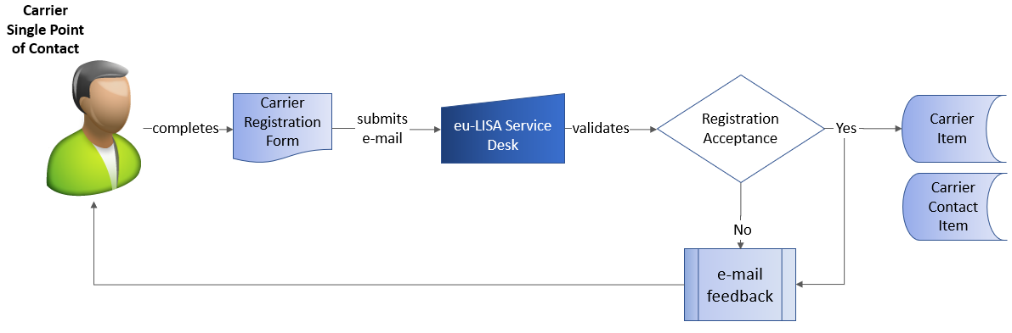

The data position to establish registration is defined in the EU implementation act referenced in section 13.1.
The registration form will prompt the Carrier SPOC to submit the following data:

Table 5 – Carrier Registration Data
# | Data | How | Mandatory or Optional
01 | Electronic copy of the Carrier’s instruments of constitution, including statutes | Attachment | M
02 | Either:  an extract of the Carrier official company registration from either at least one Member State, where applicable, or from a third country, stated in one of the official European Union or one of the Schengen Associated Countries languages  Or:  an authorisation to operate in one or more Member States, such as an Air Operator Certificate | Attachment | M
03 | Carrier declaration regarding which of the 2 documents in point 2 is submitted, and which language both documents are written in | Form Field | M
04 | the Member State or third country that issued the official company registration (including the registration number, where available) | Form Field | M
05 | The company registration number, where available | Form Field | O
06 | When the carrier registration is with a third country, the Member States in which the carrier operates or intends to operate within the next 6 months. | Form Field | O
07 | Legal name of the Carrier as well as its contact details (email address, telephone number and postal address) | Form Field | M
08 | The contact details of the legal representative of the company requesting the registration with contact details:  - name  - surname  - phone(s)  - functional or individual email address  - postal address  - The Carrier SMS number via which to receive the password to be used for decrypting email attachments.  - Time zone | Form Field | M
09 | NDA. This is optional because it can also be submitted separately | Attachment | O
10 | Similar details for Carrier SPOC back-up points of contact or other contacts, with a clarification about the role of the other contacts. This is optional because they can also be declared separately at a later stage | Form Field | O

The service desk will validate the submitted data for completeness, formatting, consistency and duplication.
If this validation fails, the service desk will contact the originator to resolve issues.
When the validation succeeds, the service desk will record the Carrier data and assign to Carrier a Submission ID, and notify Carrier about successful registration and Submission ID.
The service desk will next validate the submitted data for restrictive measures, blacklists, sanctions and if this leads to findings, eu-LISA may contact the Carrier or Member States for follow-up.

    - Carrier Contact Registration
A Carrier Contact is a person that will be interacting with the Service Desk. This may involve exchange of information under NDA, which is why such contacts are registered.
A Carrier Contact is not necessarily a person that is an employee of the same company as the Carrier SPOC. The Carrier may have contracted responsibility to another company, e.g. a Service Provider.
Contact Registration steps are depicted below:
Figure 6 –Contact Registration

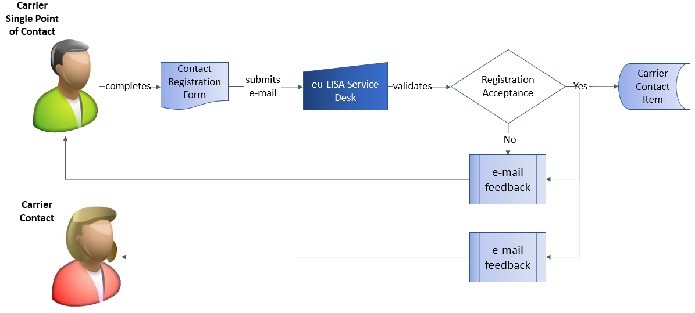
The contact registration form will prompt the Carrier SPOC to submit the following data:

Table 6 – Contact Registration Data
# | Data | How | Mandatory or Optional
01 | The contact details:  - name  - surname  - phone(s)  - functional or individual email address  - postal address  - The contact SMS number via which to receive the password to be used for decrypting email attachments.  Time zone | Form Field | M
02 | In case the Contact is an employee of the registered Carrier: Carrier Submission ID  Else: Name of the company | Form Field | M
03 | Contact role | Form Field | M
04 | In case the other company is a service provider: the name of the system that he/ she is the contact for | Form Field | O

The service desk will validate the submitted data for completeness, formatting, consistency, duplication.
If this validation fails, the service desk will contact the originator to resolve issues.
When the validation succeeds, the service desk will record the Carrier Contact data. In case the contact is belonging to a Carrier Service provider, a Submission ID for the Service Provider is identified or assigned and Carrier SPOC and Carrier Contact are notified about successful registration and Submission ID.
The service desk will next validate the submitted data for blacklisting and if this leads to findings, may contact the Carrier Contact or Carrier SPOC for follow-up.

    - NDA
Each Carrier Contact needs to complete a NDA in order to receive a decryption key for encrypting or decrypting documents being shared via e-mail during the Manual Onboarding.
The picture below shows the key steps:
Figure 7 – Non-Disclosure Agreement

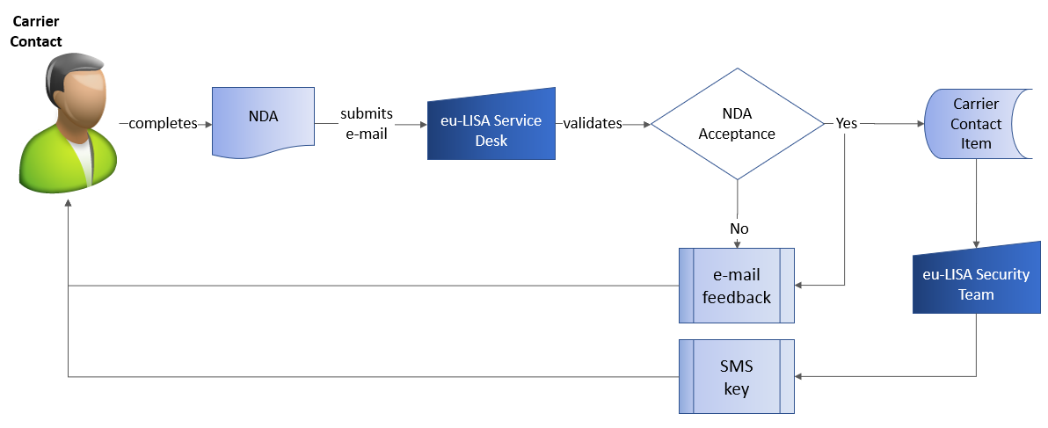
The NDA template will prompt the Carrier Contact to submit the following data:

Table 7 – NDA Data
# | Data | How | Mandatory or Optional
01 | Identification details:  - Submission ID  - Name | Form Field | M
02 | Signature confirming agreement to terms specified in the NDA | Form Field | M

The service desk will validate the submitted data for completeness, consistency, duplication.
If this validation fails, the service desk will contact the originator to resolve issues.
When the validation succeeds, the service desk will record the NDA andnotify the contact about its acceptance.
The security team will next submit the encryption key information to the Carrier Contact via text message.

    - Carrier System and System Contact Registration
This only applies to Carriers that want to register a System, with a contact that manages their system for Sys2Sys interfacing.
This may be a Service Provider contact for Carriers that have outsourced the relevant system, or a Carrier contact for Carriers that operate an in-house system.
The picture below shows the key steps:
Figure 8 – Carrier System Registration
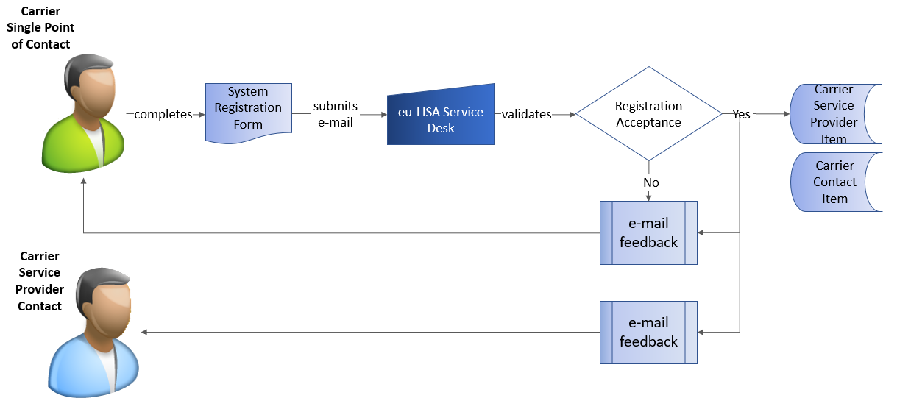
The form used, data submitted and follow up actions are the same as for Carrier Contact Registration (see section 9.3.3), except that the name of the system is now mandatory data to be provided, and the preferences for system (REST/JSON or EDIFACT, and in case of EDIFACT, which version is currently supported) are asked.
When the validation succeeds, the service desk will follow up with sharing Carrier Technical Guidance and Test documentation.
Carriers that need to register multiple systems should submit a System Registration Form for each system.

    - E-mail convention
All messages should be sent to: carriers_onboarding@eulisa.europa.eu.
Registered Carrier SPOCs are requested to use the following mail convention for initial registration requests:

Table 8 – Overview of Information Exchanged
# |  | Interaction Type | Mail convention
01 | Carrier registration |  | Use mail Title:  CARRIER REGISTRATION – Carrier name
02 | Contact registration |  | Use mail Title:  Cnnnn – CONTACT REGISTRATION – Contact Name  Or  Snnn – CONTACT REGISTRATION – Contact Name
03 | NDA |  | Use mail Title:  Cnnnn – NDA – Contact name
05 | System registration |  | Use mail Title:  Cnnnn – SYSTEM REGISTRATION – System name
06 | Deregistration |  | Use mail Title:  Cnnnn – D – Question Summary  Or  Snnn – D – Question Summary
Where Cnnnn or Snnn is the Carrier or Service Provider ID number obtained during registration (i.e.: C1234, S123).
Registered Carrier SPOCs are allowed to send e-mails with other questions, problems or complains. Different topics might be addressed using following Request Types:

Table 10 – Overview of Information Exchanged – continued
# | Data | How | Mandatory or Optional
01 | Question | A question about the elements in scope of manual onboarding support, i.e. information about:  - procedures and templates used for Carriers Manual Onboarding and Sys2Sys interfaces  - legislation aspects  - project setup  - technical aspects  - EES/ETIAS-WS evolution roadmap | Use mail Title:  Cnnnn – Q – Question Summary  Or  Snnnn – Q – Question Summary
02 | Connection Request | to address topics related to interfacing tools for Automatic Sys2Sys communication, technical documentation | Use connection request form and mail title:  Cnnnn – S – System Connection Summary  Or  Snnnn – S –System Connection Summary
03 | Incident | to address incidents or suspected defects that arose during the Sys2Sys interfaces tests | Use test incident report form and mail title:  Cnnnn – I – Incident Reference  Or  Snnnn – I – Incident Reference
04 | Complaint | to escalate issues related to received support | Use mail Title:  Cnnnn – C – Complaint Subject  Or  Snnnn – C – Complaint Subject
Where Cnnnn or Snnn is the Carrier or Service Provider ID number obtained during registration (i.e.: C1234, S123)

    - Manual Onboarding forms
Forms to be used by Carrier SPOC for registering Carriers and Carrier Contacts are attached here:

Table 11 – Registration Forms
# |  | Form | MS Word File
F01 | Carrier Registration form
F02 | Carrier Contact Registration form
F03 | Registration form for Carrier System and Service Provider contacts |  | Can be found in the Welcome Pack, which Carrier will receive after the Carrier SPOC has signed the NDA
F04 | Form for Request to be connected |  | Can be found in the Welcome Pack, which Carrier will receive after the Carrier SPOC has signed the NDA
F05 | Form to report Test Incident |  | Can be found in the Welcome Pack, which Carrier will receive after the Carrier SPOC has signed the NDA
F06 | Form to Ask Question |  | Can be found in the Welcome Pack, which Carrier will receive after the Carrier SPOC has signed the NDA
F07 | NDA Form

The contact role in the context of Manual Onboarding can be for example: - A functional e-mail address shared by Carrier SPOC and backup Carrier SPOC - The backup for the overall Carrier SPOC - The Carrier SPOC for the system to system channel - The Carrier Service Provider SPOC for the system to system channel - A technical contact for a specific topic - A staff registration (S)POC.

